Name: BALOGUN OLUWAFEMI PETER
Matric No: 220404020
Course: CSC 426

- The link below is questionnaire for the community involved
https://docs.google.com/forms/d/e/1FAIpQLSf-g1wr4GtqWEKbnjsTB_pOE-SvmeU9Qtk0C983JJ358SmXwQ/viewform

- Figure 1 below is the analysis of the issue using Ishikawa
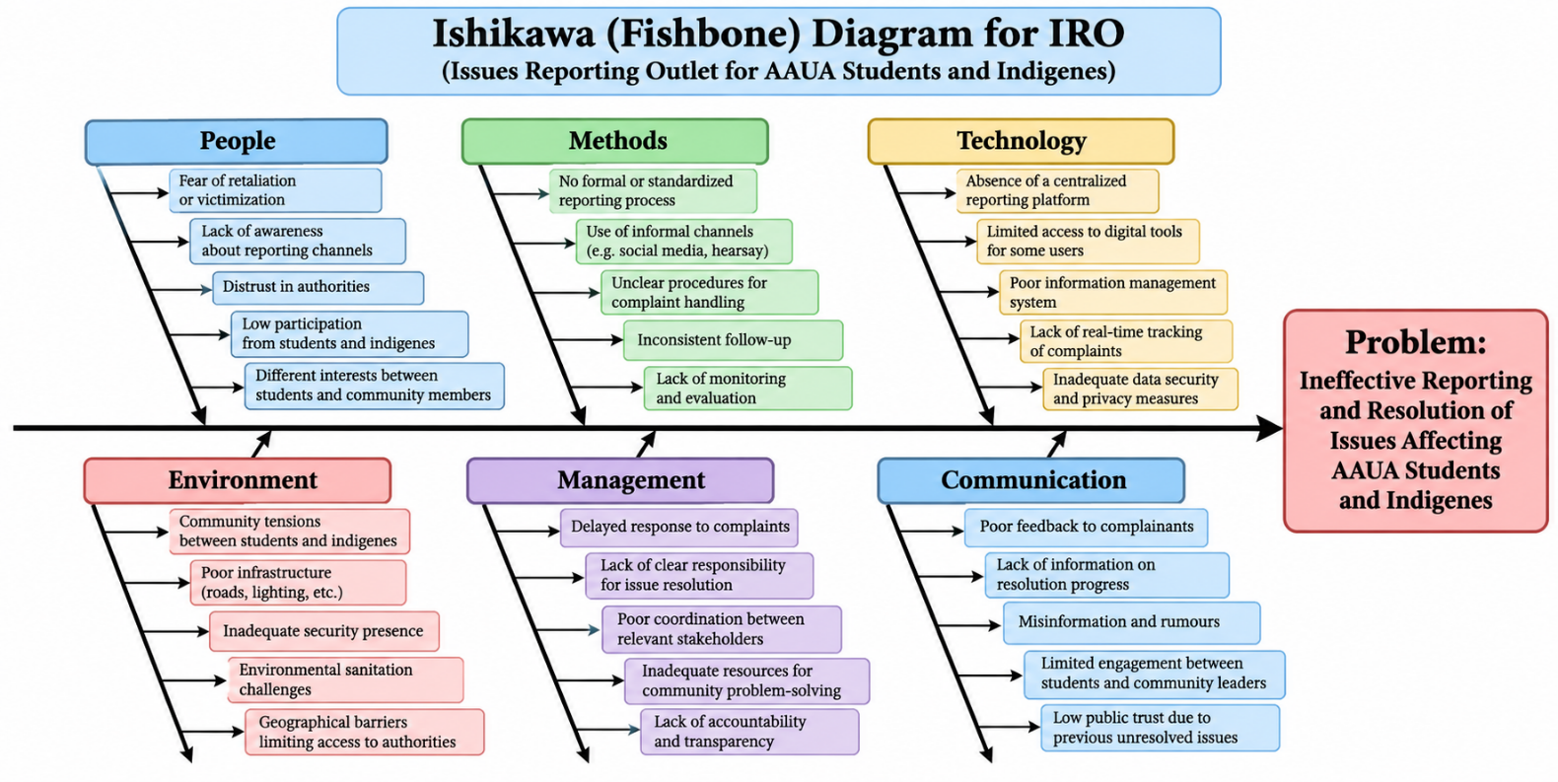
Fig 1: Analysis of the issue using Ishikawa

- Figure 2 is a screenshot showing a section of the mini web interface solution and the link attached leads to the github repository where the main code is stored

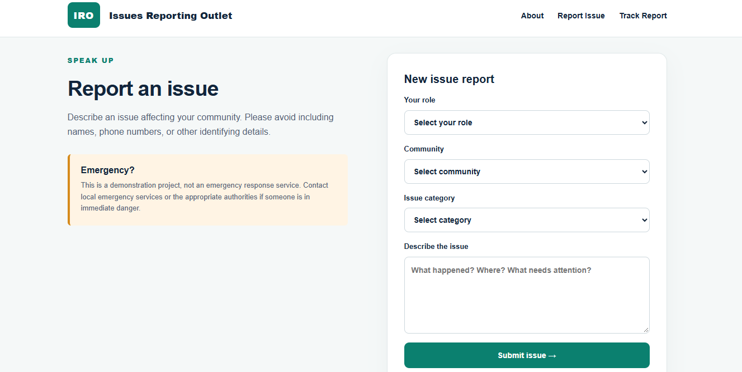
Fig 2: Screenshot showing a section of the mini web interface solution
https://github.com/Peterfem008/IRO-Assessment-of-Issues-Affecting-AAUA-Students-and-Host-Communities/tree/main

- Figure 3 is a use-case diagram showing how the system interacts

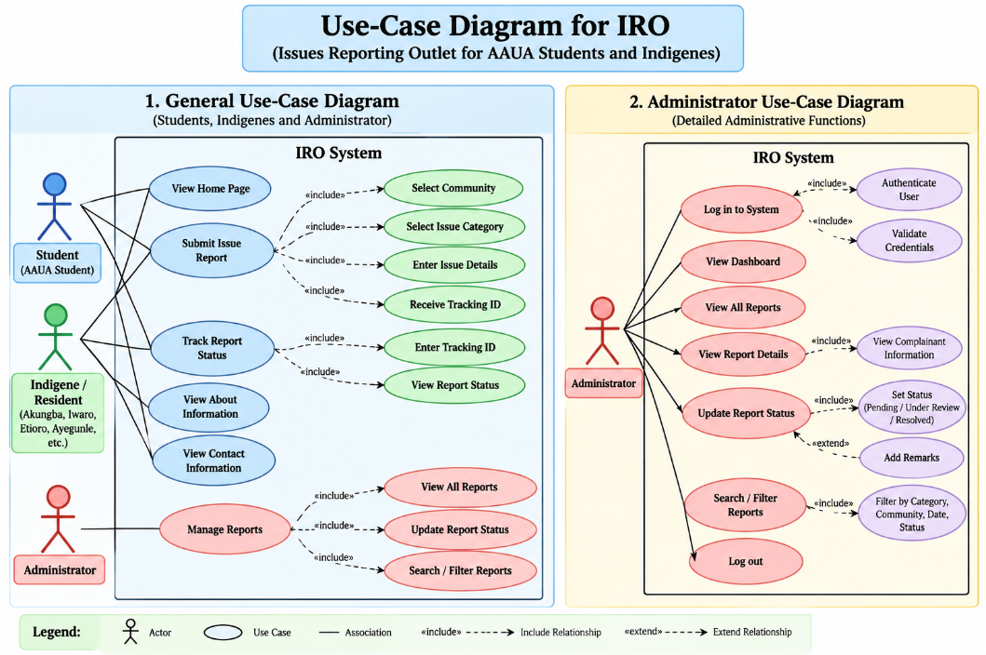

5. Software Requirements Specification
IRO | Issues Reporting Outlet
Mini Web-Based Issue Reporting System for AAUA Students and Host Communities
Version 1.0 | 19 October 2026 | Academic Prototype
Prepared for: Software Engineering Project Submission

Document control
Item | Details
Project | Issues Reporting Outlet (IRO)
Platform | Responsive PHP web application
Implementation baseline | IRO-mini.zip, PHP + SQLite
Status | Prototype; not an official or operational complaints service
Primary audience | AAUA students, Akungba, Iwaro, Etioro, Ayegunle and nearby residents

1. Introduction

1.1 Purpose
This SRS describes the actual features, component interactions, constraints and quality requirements of the IRO mini application. It distinguishes implemented functions from proposed future enhancements.

1.2 Problem statement
Students and host-community residents may face fragmented channels for reporting security, accommodation, sanitation, harassment and infrastructure issues. IRO demonstrates a single entry point for recording an issue and checking its recorded status by reference.

1.3 Scope
Included: public home/about sections, issue submission, random tracking reference generation, persistent report storage and reference-based status lookup. Excluded: user registration, administrator login/dashboard, notifications, escalation, actual investigation and resolution workflows. All newly created reports remain Pending in the current application.

1.4 Definitions
Term | Meaning
AAUA | Adekunle Ajasin University, Akungba-Akoko
IRO | Issues Reporting Outlet
SRS | Software Requirements Specification
CSRF | Cross-Site Request Forgery
Tracking reference | Random IRO-prefixed code used to retrieve limited report metadata
SQLite | Embedded relational database used by the prototype

2. Overall description

2.1 Users and operating environment
Public users are AAUA students, indigenes and residents. No login is required. The prototype runs on PHP 8.0+ with the PDO SQLite extension and is viewed in a modern desktop or mobile browser. The PHP process requires permission to create/write iro.sqlite.

2.2 Assumptions and dependencies
- Users have internet or local-network access to the hosted PHP application.
- The server has PHP, PDO SQLite and a writable project directory.
- The system is an academic demonstration; it does not promise action by authorities.
- The tracking reference must be retained by the reporter; there is no account-based recovery.

3. Functional requirements

ID | Requirement | Priority / State
FR-01 | Display home, about, report and tracking sections with navigation. | Must / Implemented
FR-02 | Accept reporter role: Student, Indigene or Resident. | Must / Implemented
FR-03 | Accept community: Akungba, Iwaro, Etioro, Ayegunle or Other. | Must / Implemented
FR-04 | Accept issue category: Security, Accommodation, Sanitation, Infrastructure, Harassment or Other. | Must / Implemented
FR-05 | Accept issue description between 15 and 2,000 characters. | Must / Implemented
FR-06 | Validate submitted fields against allowed values on the server. | Must / Implemented
FR-07 | Generate an IRO-XXXXXXXX random hexadecimal tracking reference after successful submission. | Must / Implemented
FR-08 | Store reference, role, community, category, description, status and creation timestamp in SQLite. | Must / Implemented
FR-09 | Initialize a new report with status Pending. | Must / Implemented
FR-10 | Retrieve report reference, category, community, status and submission time when a valid reference is entered. | Must / Implemented
FR-11 | Display a not-found message when no matching report exists. | Must / Implemented
FR-12 | Protect POST actions with a session CSRF token. | Must / Implemented
FR-13 | Allow authorized staff to sign in, view and update reports. | Future / Not implemented
FR-14 | Notify users and enable genuine case resolution. | Future / Not implemented

4. Non-functional requirements
ID | Requirement / acceptance criterion
NFR-01 | Usability: public submission and tracking forms must have visible labels and required-field indicators.
NFR-02 | Responsive UI: forms and navigation should remain usable on common phone and desktop widths.
NFR-03 | Security: use parameterized SQL queries, CSRF validation and HTML output escaping.
NFR-04 | Privacy: avoid collecting names, phone numbers and matriculation numbers; warn against identifying details in descriptions.
NFR-05 | Data integrity: reject invalid role/community/category values and descriptions outside 15–2,000 characters.
NFR-06 | Compatibility: run under PHP 8.0+ with PDO SQLite and modern browsers.
NFR-07 | Maintainability: keep application logic in index.php and presentation styles in assets/style.css for the mini-project scope.
NFR-08 | Reliability: store reports persistently in SQLite across normal page reloads and process restarts.
NFR-09 | Performance target: on a typical local development machine, public pages and tracking queries should usually respond within 2 seconds; not formally benchmarked.
NFR-10 | Deployment safety: do not publicly expose the SQLite file; do not use this prototype for real sensitive complaints without further security review.

5. System architecture and component interactions
Architecture: Browser (HTML/CSS forms) → PHP application (index.php) → PDO SQLite driver → SQLite database (iro.sqlite). The response returns HTML to the browser. No JavaScript or third-party API is required for the core workflow.

5.1 Main components
Component | Responsibility
Browser / UI | Displays navigation, form fields, confirmation and tracking result.
PHP request handler | Reads POST action, verifies CSRF, validates inputs, inserts or retrieves records.
SQLite database | Stores reports table and provides reference-based lookup.
Stylesheet | Provides responsive visual styling in assets/style.css.
PHP session | Stores per-session CSRF token.

5.2 Submission interaction
1. Reporter opens the Report Issue section. 2. Reporter selects role, community and category, then enters a description. 3. Browser posts action=submit and CSRF token to index.php. 4. PHP checks token and validates fields. 5. PHP generates a random reference and inserts the record through a prepared SQL statement. 6. The page displays the tracking reference. Failed validation displays an error without inserting a report.

5.3 Tracking interaction
1. Reporter opens Track Report. 2. Reporter enters an IRO-XXXXXXXX reference. 3. Browser posts action=track and CSRF token. 4. PHP queries SQLite with a prepared statement. 5. If found, the page shows reference, category, community, Pending status and creation time. Otherwise, a not-found message is displayed.

6. Data requirements
Field | Type / constraint | Purpose
id | INTEGER primary key | Internal row identifier
reference | TEXT UNIQUE | Tracking reference
role | TEXT | Student / Indigene / Resident
community | TEXT | Selected location
category | TEXT | Issue category
description | TEXT, 15–2,000 chars at application level | Report narrative
status | TEXT default Pending | Recorded progress state
created_at | TEXT default CURRENT_TIMESTAMP | Submission timestamp
Data flow and access: report descriptions are stored server-side but are not returned by the public tracking query. A tracking code is a bearer secret for limited metadata; anyone possessing it can look up that metadata.

7. Use cases
Use case | Actor | Precondition | Outcome
UC-01 View information | Student / Indigene / Resident | Page accessible | Homepage and about content displayed
UC-02 Submit issue | Student / Indigene / Resident | Valid form and CSRF token | Report saved; reference shown
UC-03 Track issue | Student / Indigene / Resident | Reference available | Limited report details shown or not-found message
Note: an Administrator actor and report status-update use cases may appear in the proposed-system UML diagram, but these are future requirements, not capabilities of the delivered mini application.

8. Interface requirements
The system uses a single index.php page with anchors #about, #report and #track. Report fields are role, community, category and description. Tracking requires a reference matching IRO- followed by eight hexadecimal characters. CSS is loaded from assets/style.css.

9. Verification and test cases
Test | Input / action | Expected result
T-01 | Open index.php | Homepage and navigation render
T-02 | Submit valid report with description >=15 chars | Success notice and unique IRO reference
T-03 | Submit description shorter than 15 chars | Validation error; no insert
T-04 | Submit invalid category through modified POST | Server rejects request
T-05 | Track existing reference | Shows category, community, Pending and date
T-06 | Track nonexistent valid-format reference | Not-found message
T-07 | Submit with invalid CSRF token | Form session error; no action
T-08 | Reload after valid submission | Stored report remains retrievable
These are prescribed acceptance tests; execution results are not asserted in this document.

10. Limitations, risks and future work
- No administrator authentication, dashboard or status update capability is implemented.
- Reports remain Pending; the interface must not imply that authorities are reviewing them.
- No emergency dispatch, investigation, moderation, attachments or messaging is provided.
- A public deployment would require HTTPS, rate limiting, stronger privacy controls, restricted database storage, backup, abuse handling and an accountable operating organization.
- The present SQLite file is created beside index.php; deployment must block web access to the file or move it outside the document root.
- Future enhancement: authenticated admin dashboard, role-based access, case audit log and secure notifications.

11. Conclusion
IRO meets the mini-project goal of demonstrating a simple reporting and tracking interface for AAUA students and surrounding communities. It illustrates the main browser, PHP and database interactions while keeping administrative resolution features clearly identified as future work.

Appendix A: Project files
index.php: PHP controller, HTML interface and database initialization. assets/style.css: responsive styling. README.md: installation and scope notes. .gitignore: excludes local database artifacts.
Appendix B: Related submissions
The Ishikawa diagram and UML use-case diagram are separate project artifacts. Any administrator functionality shown in a conceptual diagram should be marked “proposed extension” to match the delivered implementation.

